**CHAPTER III  
PROBLEM ANALYSIS**

Changes in motherboard design and technology continues to evolve. In the early 2000s expanded integration. Motherboards now feature sound and VGA are directly attached to the body, other terms onboard. Other features that can now be obtained from some form of connectivity motherboard USB, FireWire, and LAN Card.

Computer motherboards, especially prepared on the PC motherboard components and ports needed to build a system. Following this, the author will explain what ports and components of what is contained on the motherboard.

**III.1 . MOTHERBOARD Component And Function**

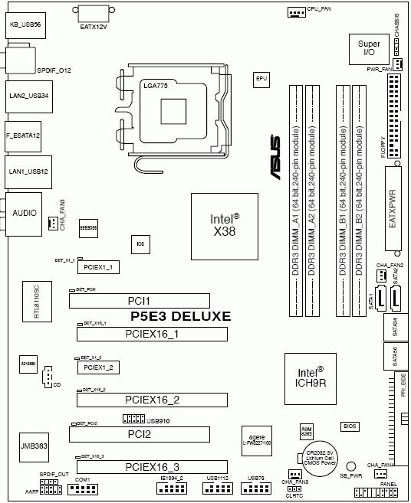

**Figure 3.1 Diagram Block of The Motherboard (REF :** [**http://www.3dnews.ru/556162/page-2.html**](http://www.3dnews.ru/556162/page-2.html))

A computer has many components, each with their own roles and functions. The role of the motherboard is to allow all these components to communicate with each other. Considering the fact that all the other components are installed on the motherboard or connected to it, it is safe to say that the motherboard is the central piece of a PC, the component that brings it all together. Followingthis, the author will discuss any components on the motherboard, and what are its functions.

1. **Chipset**

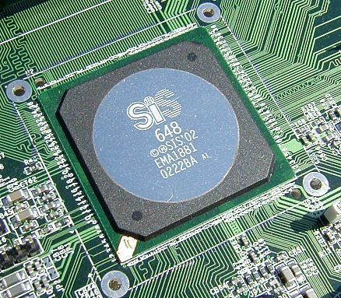

**Figure 3.2 Chipset (REF :** [**http://techreport.com/r.x/sis-648/sis648.jpg**](http://techreport.com/r.x/sis-648/sis648.jpg))

Components of a motherboard that has a very important role is the chipset. An intelligent device which basically serves as a bridge that connects the data flow processor with a variety of external components and buses.Usually this type of chipset which is the benchmark for determining and assessing the features and capabilities of a motherboard.

There are two types of chipsets are popular among computer users, the Intel chipset that can only be used for CPUs Intel and AMD chipsets for AMD processor output. Both groups also subdivided to various types of generation chipset continues to grow.

Generally, the chipset designed specifically to support the series or specific processor models should not be arbitrary, before being installed on a computer will usually be made between the chipset calculation, the amount of RAM you want to install, processor type and design of the motherboard itself. The more advanced chipset used, the more advanced motherboards will also perform many functions in a computer.

As an illustration, the type of chipset used on the motherboard will have an effect on some of the following important points:

1. The type of processor that can be used on the motherboard
2. Completeness port I / O capable supplied.
3. Type of display adapters that can be used
4. This type of memorythatcansupport themaximumcapacity ofthe PC systemandmemorythat can be usedon the motherboard
5. Completeness of additional features, such as LAN cards, modems, and sound card. Usually there is a chipset that provides this feature is already on board in its motherboard

If the first chipset technology is still very limited, now there are several types of chipsets that can support more than one type of RAM as well. One example is the i91 Intel chipset that can work with an Intel Pentium 4 and Celeron configuration using DDR or DDR2. Along with the progress of time, the development of chipsets continue to occur, but it cannot necessarily happen, because it must be adapted to the technological advances that occurred on some other computer hardware.

In carrying out its functions, the chipset is usually assisted by a number of components that have a significant role. Here are two basic components which are usually supporting motherboard chipset components:

1. Northbridge / MCH

Northbridge is the name used by AMD, VIA and some other hardware printer companies, while manufacturers Intel prefers to call it by the name of MCH which stands for Memory Controller Hub. Referred to as anything, basically Northbridge functionality remains the same, namely to act as part of a chipset in the exchange of data which is internal, such as the video card, processor and memory.

In the system works, Northbridge cooperate with the Southbridge chip. If broken down further, Northbridge duty control or handle the communication between the CPU, RAM, AGP or PCI Express, and the Southbridge. Northbridge also plays a role determining the amount, type and speed of the CPU that can be attached to the motherboard, including determining the amount, speed and type of RAM that can be used.

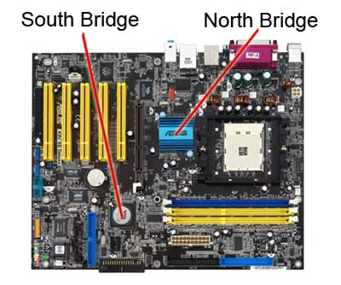

**Figure 3.3 Southbridge and Northbridge (REF :** [**http://s.hswstatic.com/gif/motherboard-bridges.jpg/**](%20http://s.hswstatic.com/gif/motherboard-bridges.jpg/)**)**

1. Southbridge

Southbridge is a designation for the auxiliary component that connects Northbridge components or other peripherals. The actual task of these two components can be said to be almost the same, only if Northbridge tends to function as a regulator of internal problems, Southbridge actually functioned as a regulator of external issues related to I / O and humans.

If broken down further, Southbridge has several important functions such as controlling the IDE bus, USB, support Plug and Play, PCI bridge and Isa, control the keyboard and mouse, control the power management features, and a number of other devices.

Besides the differences between the Southbridge and Northbridge are connecting lines they use each to get in touch with other computer hardware. If Southbridge using the connecting line speed (bus speed) slower (example: PCI bus and ISA bus), Northbridge precisely using the connecting lines far removed faster.

The figure belowisthe difference between the Southbridge and Northbridge :

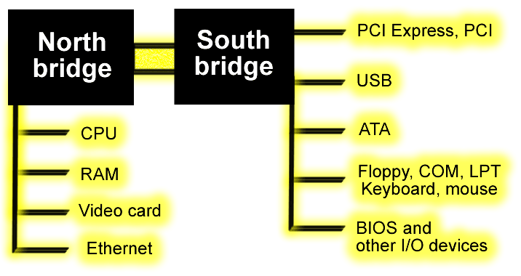

**Figure 3.4 The Difference of Northbridge & Southbridge (REF :** [**http://www.karbosguide.com/books/pcarchitecture/images/906.png**](http://www.karbosguide.com/books/pcarchitecture/images/906.png))

1. System-on-Chip

Besides chipset consists of a combination between the Northbridge and Southbridge, some chipset that has used the concept of a system chip or system-on-chip. Usually this type chipset has been providing hardware components are already on-board in a motherboard, for example, VGA and modem

.

1. **CPU Socket**

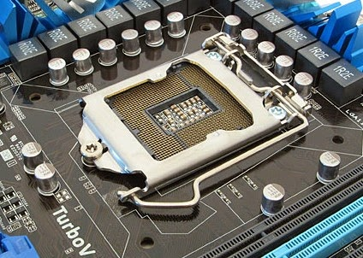

**Figure 3.5 CPU Socket (REF :**[**http://www.pintarkomputer.com/2015/04/bagian-bagian-komponen-motherboard-dan-fungsinya.html**](http://www.pintarkomputer.com/2015/04/bagian-bagian-komponen-motherboard-dan-fungsinya.html))

This is where the processor is installed, as one part of a motherboard that has a very large role on the course of the cycle of data information in a computer. Socket CPU typically consists of various types that determine what model processor that can be installed in the socket. So then each socket having each specialization, where only certain socket that attaches specific processor anyway. Some examples for the CPU Socket computer motherboard is a ZIF (Zero Insertion Force) or better known as Socket 7.

This is the CPU Socket older models are quite popular because of its advantages are compatible processors made by Intel, AMD, or Cyrix. Other CPU Socket, Socket 370. Also popular are The socket is similar to Socket 7 but the number of pins as the name suggests, 370 seeds. This socket can only be mated with processors made by Intel only. While the socket is specifically designed for AMD processors and quite popular is Socket A. A term used to designate the brand AMD Athlon processor. For a family of Intel Pentium II and III, which are used slot called Slot 1, while motherboards that support AMD processors use Slot A for type of slot like that.

1. **PCI Slot**

The next component is the motherboard PCI slot. PCI slot is short for Peripheral Component Interconnect. Basically PCI is a bus that is designed to handle multiple hardware. PCI concept was first realized in June 1992 under the name PCI version 1.0.

Since that time this component is still used today, of course, with a number of cutting-edge development makes it increasingly effective.One development of the PCI slot is used as a PCI Express expansion slot (slot additional or external) on a computer.

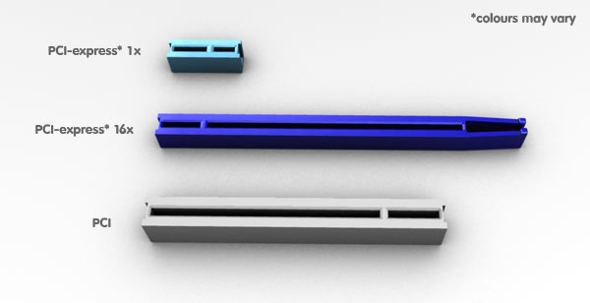

**Figure 3.6 PCI Slot(REF :**[**http://www.pcityourself.com/images/content/choosing/pciDiagram.jpg**](http://www.pcityourself.com/images/content/choosing/pciDiagram.jpg)**)**

PCI Express is divided into two tailored according to their respective functions, such as:

1. PCI Express x16 slot

Is a special slot that can be used or fitted with the latest generation VGA card.

1. PCI Express x1 slot

Is a slot to install peripherals (card) other than the VGA card.

1. **AGP Slot**

AGP slot is used to insert the AGP Card. AGP or stands for Accelerated Graphics Port, is a slot for a graphics card that is intended for3D gaming. They are onthe sidePCIslot

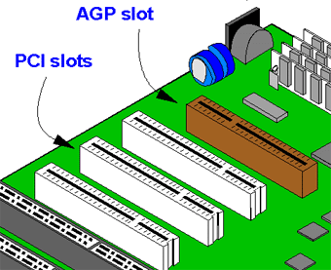

**Figure 3.7 AGP Slot (REF :**[**http://common.ziffdavisinternet.com/encyclopedia_images/_AGP.GIF**](http://common.ziffdavisinternet.com/encyclopedia_images/_AGP.GIF)**)**

1. **Memory Slot**

A memory slot, memory socket, or RAM slot is what allows computer memory (RAM) to be inserted into the computer. Depending on the motherboard, there may be 2 to 4 memory slots (sometimes more on high-end motherboards) and are what determine the type of RAM used with the computer.

The most common types of RAM are SDRAM and DDR for desktop computers and SODIMM for laptop computers, each having various types and speeds. In the picture below, is an example of what memory slots may look like inside a desktop computer. In this picture, there are three open available slots for three memory sticks

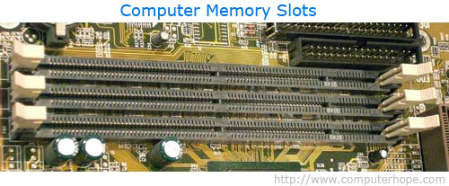

**Figure 3.8 Memory Slot (REF :**[**http://www.computerhope.com/jargon/m/memoslot.htm**](http://www.computerhope.com/jargon/m/memoslot.htm)**)**

When buying a new computer or motherboard, pay close attention to the types of RAM the memory slots, so you are familiar with what type of RAM to buy for your computer. It is also important to note how many available memory slots are available in your computer. It is not uncommon for computers to have all memory slots occupied, which means if you wanted to upgrade your computer memory some or all of the memory would need to be removed first.

1. **Heat Sink**

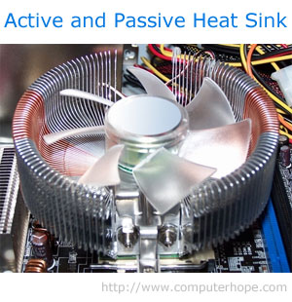

**Figure 3.9 Heat Sink (REF :**[**http://www.computerhope.com/jargon/h/heatsink.htm**](http://www.computerhope.com/jargon/h/heatsink.htm)**)**

A heat sink is an electronic device that incorporates either a fan or a peltier device to keep a hot component such as a processor cool. There are two heat sink types : active and passive.

1. Active heat sinks

Utilize power and are usually a fan type or some other peltier cooling device. If you are looking to purchase an active heat sink, it is recommended that you purchase fans with ball-bearing motors that often last much longer than sleeve bearings. Sometimes these types of heat sinks are referred to as a HSF, which is short for heat sink and fan.

1. Passive heat sinks

Are 100% reliable, as they have no mechanical components. Passive heat sinks are made of an aluminum-finned radiator that dissipates heat through convection. For passive heat sinks to work to their full capacity, it is recommended that there is a steady air flow moving across the fins. The above picture is an example of a heat sink that is both active and passive.

1. **Power Connector**

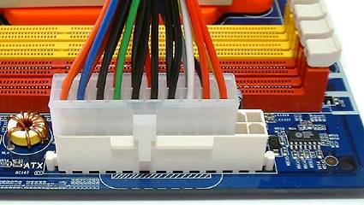

**Figure 3.10 Power Connector(REF Power Connector:**[**http://media.bestofmicro.com/Z/P/243637/original/atx.jpg**](http://media.bestofmicro.com/Z/P/243637/original/atx.jpg)**)**

No computer component can operate without power, and a motherboard is no exception. The power connector, commonly a 20 or 24-pin connector, can be situated either near the right edge of the motherboard, or somewhere close to the processor socket on older motherboards.

This is where the power supply’s main connector gets attached, providing power to the motherboard and all the other components. Newer motherboards have an additional 4-pin or 8-pin connector near the processor, used to supply additional power directly to the processor.

1. **Serial ATA (SATA ) Slot**

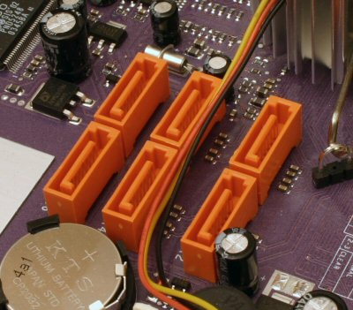

**Figure 3. 11 SATA Slot (REF:<https://sharpsblogorama.files.wordpress.com/2010/11/sata.jpg>)**

SATA connectors are also known as Serial ATA connectors. SATA stands for Serial Advanced Technology Attachment, which is usefulfor connecting serial ATA devices.

1. **Primary And Secondary IDE slot**

Primary and Secondary IDE connectors Interfaces also called IDE or PATA connector. IDE stands for Integrated Device Electronics, the support for IDE devices, such as hard disks and CD and DVD drives.

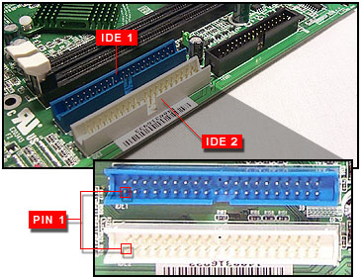

**Figure 3.12 IDE Slot (REF:**[**http://panam.gateway.com/s/MOTHERBD/MSI/2513146/251314607.jpg**](http://panam.gateway.com/s/MOTHERBD/MSI/2513146/251314607.jpg)**)**

1. **BIOS**

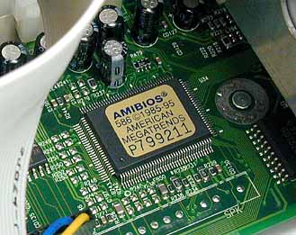

**Figure 3.13 BIOS (REF:<http://s.hswstatic.com/gif/bios.jpg>)**

BIOS stands for Basic Input Output System, which is also one important part of the motherboard chip, to perform POST (Power On Self Test). BIOS stands for Basic Input-Output System, but also often associated with a word in Greek 'bioc'. which means 'life'. Simply put, the BIOS is a chip that stores the software to control the hardware and serves as an interface between the hardware and the operating system (OS). BIOS isused by the computer to prepare process boot (startup) and check the readiness of the system and hardware before the computer starts.

. To find out a bit further, here are some of the BIOS functions in general : BIOS runs initialization and testing of computer hardware that exists, which in the language of the BIOS functions known as Power On Self Test alias POST. When the computer starts is turned on, the BIOS will load the command and immediately run the operating system so that the computer can run properly.

BIOS has contributed greatly to the basic system configuration settings on the computer such as the current date and time. And participate in areas such as storage configuration, the configuration of the boot process, and keep the computer in order to remain stable. By using a system called BIOS Runtime Services, BIOS help operating systems and applications in the process of setting up the computer hardware in an organized manner. BIOS provides low-level communication interface, and can control some types of computer hardware such as keyboards.

1. **CMOS**

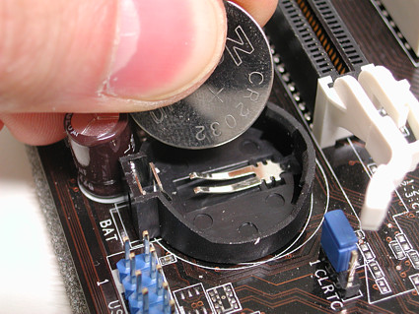

**Figure 3.14 CMOS (REF:<https://ramanathan.files.wordpress.com/2007/01/cmos_battery1.jpg>)**

Alternatively referred to as a Real-Time Clock (RTC), Non-Volatile RAM (NVRAM) or CMOS RAM, CMOS is short for Complementary Metal-Oxide Semiconductor. CMOS is an on-board, battery powered semiconductor chip inside computers that stores information. This information ranges from the system time and date to system hardware settings for your computer. The picture shows an example of the most common CMOS coin cell battery used to power the CMOS memory.

The Motorola 146818 chip was the first RTC and CMOS RAM chip to be used in early IBM computers; capable of storing a total of 64 bytes of data. Since the system clock used 14 bytes of RAM, this left an additional 50 bytes for storing system settings. Today, most computers have moved the settings from CMOS and integrated them into the Southbridge or Super I/O chips.

The standard lifetime of a CMOS battery is around 10 Years. However, this can vary depending on the use and environment in which the computer resides. If the battery fails, the system settings, date, and time will not be saved when the computer is turned off until it has been replaced.

1. **Capacitors**

A Capacitors capacitor is a component made of two or sets of two conductive plates with a thin insulator between them and wrapped in a ceramic and plastic container. When the capacitor receives a direct current (DC), a positive charge builds up on one of the plates (or set of plates) while a negative charge builds up on the other. This charge, which is measured in microfarads on a computer capacitor, remains in the capacitor until it is discharged. In the image to the right, is an example of what a capacitor may look like on a computer motherboard.

Electrolytic capacitor on a computer motherboardAnother common type of capacitor is an electrolytic capacitor, which is a higher capacitance capacitor in a smaller package. In the bottom picture to the right, is a picture and an example of these types of capacitors.

Like any other component in a computer, capacitors in a computer can fail, and when they do can cause the computer or the component to fail. In the case of a motherboard, when a motherboard capacitor fails the computer will no longer boot, and the capacitor needs to be replaced or a new motherboard needs to be put in the computer.

In the picture below, is an example of an ABIT VP6 motherboard with blown capacitors and one example of how a capacitor may fail. Blown capacitors can be replaced, but for most users replacing the motherboard is often the easiest solution.

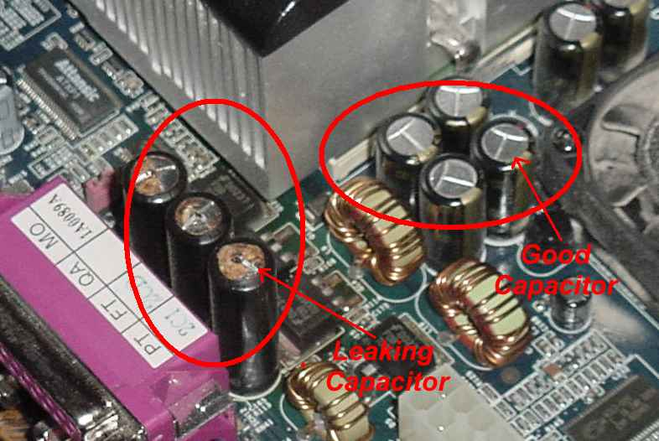

**Figure 3.15 Capacitors (REF:**[**http://www.thenakedpc.com/dan/Bulging_Capacitors/close-up.jpg**](http://www.thenakedpc.com/dan/Bulging_Capacitors/close-up.jpg)**)**

**III.2. MOTHERBOARD Port And Function**

A computer unit consists of a CPU, Monitor, Keyboard and Mouse. CPU which is a unit or a console system has multiple ports. Port on the computer functions as the interface between a computer with the computer or the unit (device) other. Generally, the port is used to connect a monitor, keyboard, mouse, modem and other peripherals. Port has its own standard form, such as a port for the keyboard are round.

Desktop computers were first invented, has two ports are serial ports and parallel ports. Cabling monitor, keyboard and mouse should be in accordance with the port. Installation error may cause malfunction of the computer. To be able to put the port in accordance with its position, the following are some of the console port.

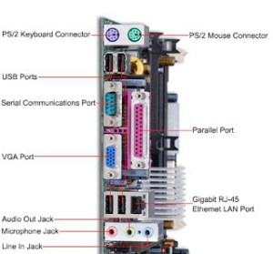

**Figure 3.16 Port of Motherboard (REF :** [**https://balyaaufa.wordpress.com/sistem-komputer/port-dan-slot-pada-motherboard/**](https://balyaaufa.wordpress.com/sistem-komputer/port-dan-slot-pada-motherboard/)**)**

1. **Serial Port**

Serial ports, these port shave nine pins are used to connect amouse, joy stick and an external modem. Serial port works by sending data one bit at a time over a single cable.

1. **Parallel Port**

Parallel port, port is used to connect the CPU to the external modem, and printer and other peripherals that have a cable to the parallel port.  
The parallel port works by sending and receiving multiple bits at a time through a set of wires. Included in the parallel port is the port connecting printers, modems, and disk drive connector port.

1. **PS / 2 Ports**

Often referred to as the mouse port or keyboard port, the PS/2 port was developed by IBM and is used to connect a computer mouse or keyboard to an IBM compatible computer. The PS/2 port is a mini DIN plug that contains six pins and is still found on all IBM compatible computers today, however, is starting to be replaced by USB.

The picture to shows what the PS/2 ports may look like on the back of your computer. As can be seen by both of these pictures many computers have adopted the color codes purple and teal as identifications for each of the port. The mouse is teal and the keyboard is purple.

1. **Sound Card Port**

Alternatively referred to as an audio output device, sound board, or audio card. A sound card is an expansion card or IC for producing sound on a computer that can be heard through speakers or headphones. Although the computer does not need a sound device to function, they are included on every machine in one form or another; either in an expansion slot (sound card) or on the motherboard (onboard).

Sound card connections :

Back of computer sound card The picture is an example of a sound card audio ports or audio jacks on the back of your computer, associated colors, and the connector symbols.

1. Digital Out (White or Yellow) (words: "Digital" or "Digital Out") - Used with surround sound or loudspeakers.
2. Sound in or line in (Blue) (Arrow pointing into waves) - Connection for external audio sources, e.g. tape recorder, record player, or CD player.
3. Microphone or Mic (Pink) (Microphone) - The connection for a microphone or headphones.
4. Sound out or line out (Green) (Arrow pointing out of waves) - The primary sound connection for your speakers or headphones. This sound card also has a second (black) and third (orange) sound out connector.
5. Firewire (Not pictured) - Used with some high-quality sound cards for digital video cameras and other devices.
6. MIDI or joystick (15 pin yellow connector) - Used with earlier sound cards to connect MIDI keyboard or joystick.

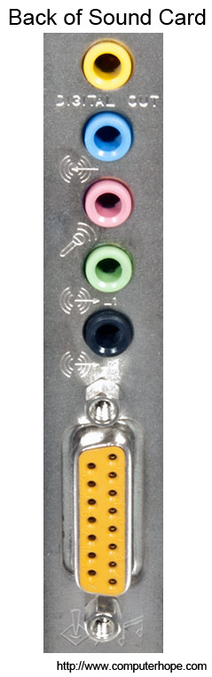

**Figure 3.17 Port Sound (REF :** [**http://cdn.computerhope.com/back-of-sound-card.jpg**](http://cdn.computerhope.com/back-of-sound-card.jpg)**)**

1. **USB Port**

USB (Universal Serial Bus) port is a multi-function port that can be used on multiple devices or other peripheral such as mouse, keyboard, modem, wireless card, and so forth. USB portis a development of the serial port.

1. **VGA Port**

A Video Graphics Array (VGA) connector is a three-row 15-pin DE-15 connector. The 15-pin VGA connector is found on many video cards, computer monitors, and high definition television sets. On laptop computers or other small devices, a mini-VGA port is sometimes used in place of the full-sized VGA connector.

DE-15 has been conventionally referred to ambiguously as D-sub 15, incorrectly as DB-15 and often as HD-15 (High Density, to distinguish it from the older and less flexible DE-9 connector used on old VGA cards, which has the same E shell size but only two rows of pins.

VGA connectors and cables carry analog component RGBHV (red, green, blue, horizontal sync, vertical sync) video signals, and VESA Display Data Channel (VESA DDC) data. In the original version of DE-15 pinout, one pin was keyed by plugging the female connector hole; this prevented non-VGA 15 pin cables from being plugged into a VGA socket. Four pins carried Monitor ID bits which were rarely used; VESA DDC redefined some of these pins and replaced the key pin with +5 V DC power supply.

The VGA interface is not engineered to be hotpluggable (so that the user can connect or disconnect the output device while the host is running), although in practice this can be done and usually does not cause damage to the hardware or other problems. However, nothing in the design ensures that the ground pins make a connection first and break last, so hotplugging may introduce surges in signal lines which may or may not be adequately protected against. Also, depending on the hardware and software, detecting a monitor being connected might not work properly in all cases.

1. **LAN Port**

LAN **(L**ocal **A**rea **N**etwork port) An RJ-45 Ethernet socket on a computer or network device such as a switch or router. All client machines, servers and network devices on the local network are cabled together at their LAN ports.

1. **HDMI Port**

HDMI (High-Definition Multimedia Interface) is a proprietary audio/video interface for transferring uncompressed video data and compressed or uncompressed digital audio data from an HDMI-compliant source device, such as a display controller, to a compatible computer monitor, video projector, digital television, or digital audio device.